Akademia Górniczo-Hutnicza im. Stanisława Staszica w Krakowie  
Wydział Energetyki i Paliw  
Katedra Zrównoważonego Rozwoju Energetycznego

**Renewable Energy**

**Laboratory activity**

Introduction to TRNSYS 17 dynamic simulation software

**REPORT**

***Savvas Liapis***

**Scope of the laboratory activity**

The laboratory aims:

1. In the acquaintance with the TRNSYS software.
2. To implement changes in a simple solar collector system, simulate the behavior of the system and portray the results taken form the simulation.

**Description of the model of solar domestic hot water system**

The main components of the domestic hot water system are:

* Collectors: this component models the thermal performance of a solar collector. We can change the parameters depending on our needs.
* Storage tank: models the performance of a fluid-filled sensible energy storage tank. We can make multiple levels of water temperatures in the tank in order to get more realistic results

The solar domestic hot water system has some components that regard the input parameters of the simulation such as:

* Weather: Inserts information about the weather , water temperature, effective sky temperature, in a certain place throughout the year with hourly timesteps
* Water Draw: creates water draw forcing functions that follow a pattern (the way domestic water is used)
* Controller: checks the temperature of the water tank and the collectors and closes or opens the water flow to the collector
* Water pump: It is controlled through the controller and it sends water to the collector.
* Pipes: the are used to better

In addition there are some parameters that serve in the monitoring of the simulation and the results printing such as:

* Integrators: integrates daily stats (of power for example) in order to get some measurements (for example energy)
* Plotters
* Printers: print the results in order to take metrics we need
* Equations : the take some integrated measurements and give back equations that describe things that we want to

**Description of the activity carried out**

The activity carried out included certain parts:

1. Understand how the components work
2. Make changes to the default version of the domestic solar system in order to better represent the reality (ex. Add pipes, change the collector, change the weather)
3. Understand how to get the measurements and get the metrics that are better to evaluate the performance of the model
4. Develop some tasks to represent how the system works under different circumstances ( different weather )

**Results of the simulation (graphs and data)**

18.1. Add components that allows you to determine the trend in the solar collector's power during the year (hint: use an existing plotter to connect the thermal power of the collector or use a new one).

In order to get the thermal power, we used the correct equation, we integrated the results and printed them. In addition we added a plotter and a printer to get the results

18.2. Compare the solar collector power changes for the three selected locations for the same day (select locations located on different continents) in the last day of the year .

My 3 locations were:

* Thessaloniki, Greece
* Casablanca, Morocco
* Toronto, Canada

1. Heat transfer rates

Casablanca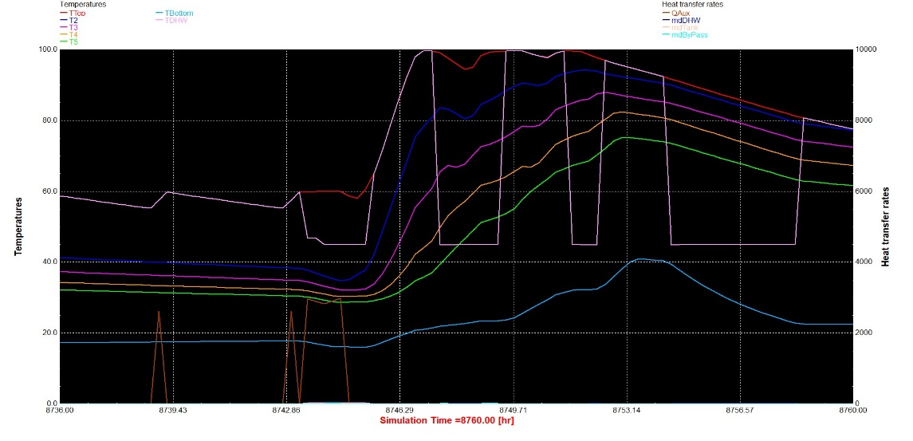

Toronto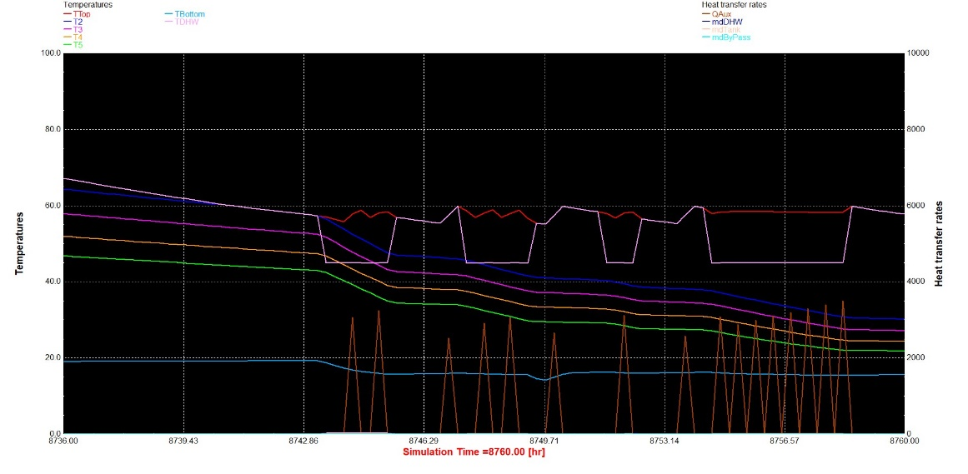

1. Weather -solar loop :

Thessaloniki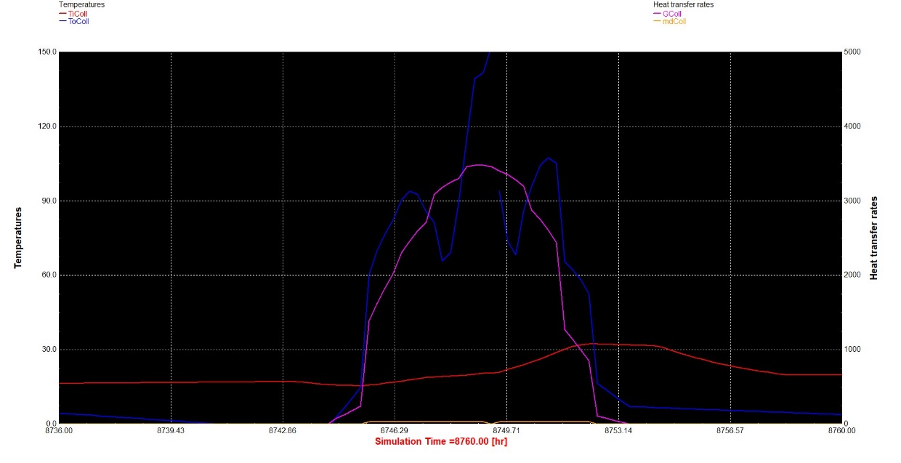

Casablanca

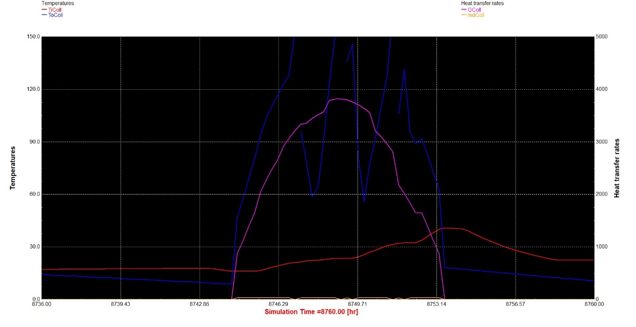

Toronto

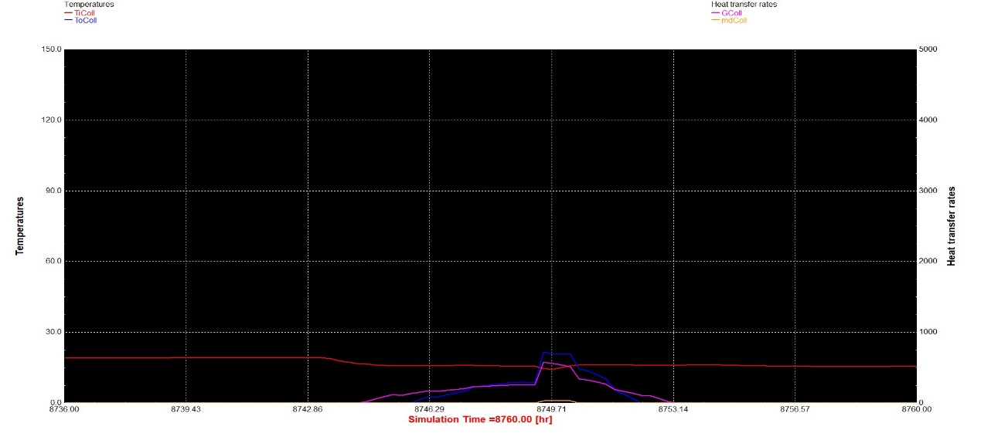

1. Trend in solar collectors power :

Thessaloniki

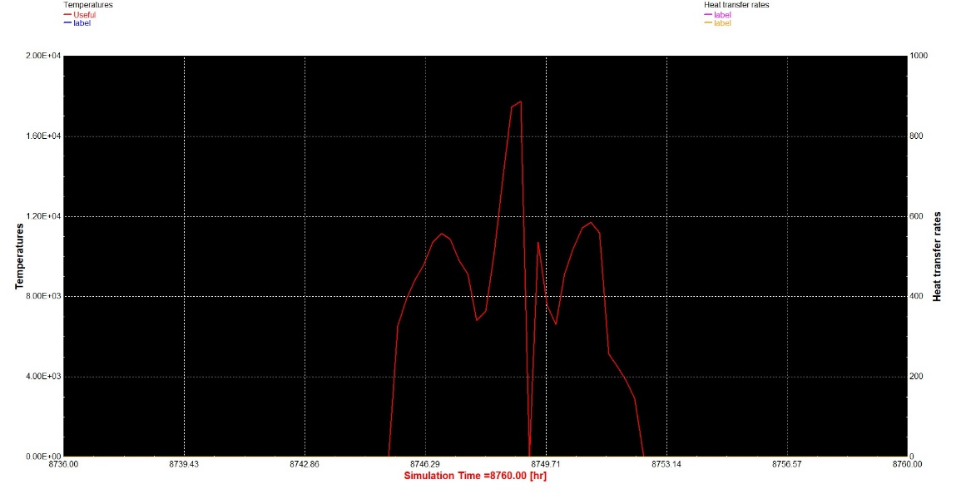

Casablanca

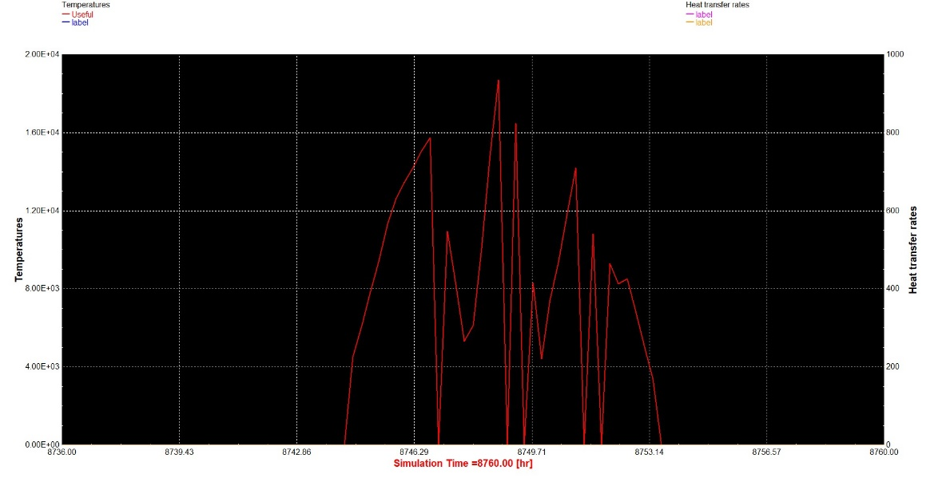

Toronto

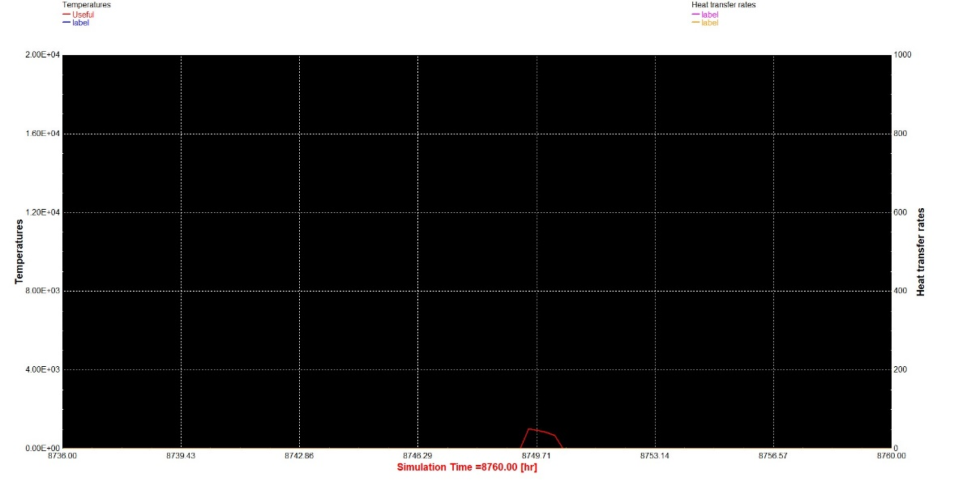

18.3. Compare the annual energy yield from the solar collector for selected locations.

|  |  |  |  |  |  |  |
| --- | --- | --- | --- | --- | --- | --- |
|  | IColl (x106) | QuColl  (x107) | QDHW (x106) | QAux (x106) | EtaColl  (x10-1) | FSol  (x10-1) |
| Thessaloniki | 4.7142 | 1.54058 | 9.8648 | 2.3765 | 6.53583 | 7.59093 |
| Casablanca | 6.8061 | 2.0829 | 9.86416 | 3.8119 | 6.12071 | 9.613558 |
| Toronto | 5.62958 | 1.6686 | 9.86317 | 1.73719 | 5.92827 | 8.23870 |

18.4 Compare the annual solar collector efficiency and energy yield form the flat-plate and evacuated tube solar collector

|  |  |  |
| --- | --- | --- |
|  | HeatLoss_TRNSYS(x105) | HeatLoss_Equation(x105) |
| Thessaloniki | 6.4283 | 5.6375 |
| Casablanca | 9.0057 | 8.0527 |
| Toronto | 8.0973 | 7.046 |

18.5. Calculate the yearly domestic hot water energy demand (hint: add a calculator that calculates the instantaneous thermal power of the domestic hot water supplied to the user (mass flow*cp*(temperature supplied to the user-temperature of water entering the system)) and use the integrator and printer to carry out the results).

The results for Toronto were : 9.863205x106